

**Data Brief: Opioid-related Overdose Deaths Among Massachusetts Residents**

Massachusetts Department of Public Health Posted: JANUARY 2016

This report contains both confirmed and estimated data through 2014 and 2015. The number of confirmed cases of unintentional opioid overdose deaths for 2014 (n=1099) represents a 65% increase over 2012 (n=668) and a 21% increase over cases for 2013 (n=911). In order to obtain timelier estimates of the total number of opioid overdose deaths in Massachusetts, confirmed and probable, DPH analysts used predictive modeling techniques for all cases not yet finalized by the Office of the Chief Medical Examiner. Based on the data available as of 12/10/2015, DPH estimates that there will be an additional 61 to 89 deaths in 2014, once these cases are finalized.



Note: These counts are complete as of the date that the stat’s statistical file was closed

DPH analysts have also made month-by-month estimates for each month for all intents from June 2014 through September 2015. We only report data for those months in 2015 for which at least 80% of deaths have a recorded final cause of death. This data should be considered preliminary, and not necessarily representative or depictive of any larger trend.

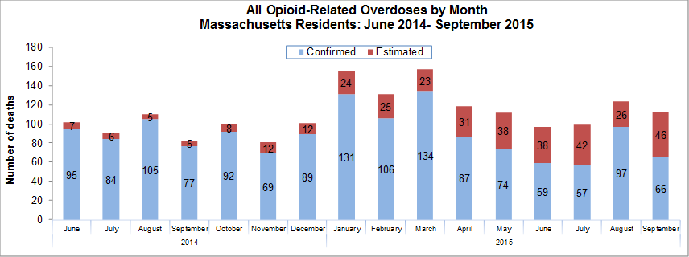

**Rate of Unintentional Opioid Deaths**

The estimated rate of unintentional opioid-related overdose deaths, which includes deaths related to heroin, reached levels in 2014 previously unseen in Massachusetts. The estimated rate of 17.4 deaths per 100,000 residents for 2014 is the highest ever for unintentional opioid overdoses and represents a 228% increase from the rate of 5.3 deaths per 100,000 residents in 2000.



1 Unintentional includes unintentional and undetermined intents to account for a change in policies related to assignment of manner of death in overdose deaths that occurred in 2005. Opioids include heroin, opioid-based prescription painkillers, and other unspecified opioids. This report tracks opioid-related overdoses due to difficulties in identifying heroin and prescription opioids separately.

**Technical Notes**

The figures cited here for 2014 and 2015 are based on confirmed and estimated data. The Department regularly reviews projections as more information becomes available. Should the estimates change to any significant degree, updates will be posted. DPH used closed analytic files for the years 2008 – 2012 to create and then refine a model to predict the likelihood that the cause of death for any person will be an opioid-related overdose once finalized. DPH later added 2011-2013 data from the Medical Examiner’s Office (OCME) to refine the Department’s model for 2011-2013, which improved the model significantly. Finally, DPH applied this model to the 2014 - 2015 open files to estimate the number of pending cases that will be an opioid-related overdose once a determination is made by the OCME. Included in the final model are: age, race, education, gender, year of death, place of death, autopsy status, Medical Examiner’s notes, and latent class geography. DPH added this estimate to the number of confirmed cases in order to estimate the total number of opioid-related overdoses. Due to missing information on intent in the open files, the models predict the total number of fatal opioid-related overdoses. In order to estimate the numbers that are considered unintentional, the Department applied the average percentage of total opioid-overdose deaths that were considered unintentional for the previous 5-year period (94%) to the total estimate.